Scenario 1 - Student Academic Performance Dashboard

Program
library(ggplot2) library(dplyr)
set.seed(1) n &lt;- 60
dept &lt;- sample(c('CSE','AI','IT','ECE'), n, replace=TRUE) att &lt;- sample(50:99, n, replace=TRUE)
marks &lt;- att*0.7 + rnorm(n, 0, 8)
df1 &lt;- data.frame(Attendance=att, Marks=marks, Department=dept)

df1$AttBin &lt;- cut(df1$Attendance, breaks=c(50,60,70,80,90,100),
labels=c('50-59','60-69','70-79','80-89','90-99'), right=FALSE)
grouped &lt;- df1 %&gt;% group_by(AttBin, Department) %&gt;% summarise(Marks=mean(Marks), .groups='drop') ggplot(grouped, aes(x=AttBin, y=Marks, color=Department, group=Department)) +
geom_line(size=1) + geom_point(size=2) + labs(title="Attendance vs Internal Marks by Department",
x="Attendance (%) Range", y="Average Internal Marks") + theme_minimal()

Output
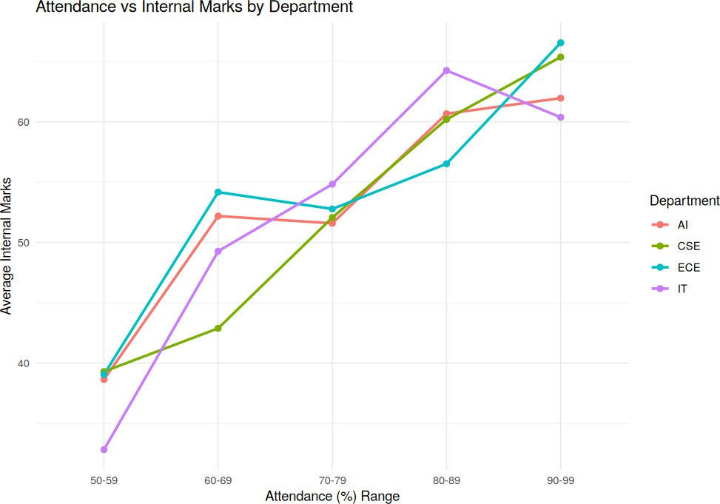

Scenario 2 - Electric Vehicle Market Analysis

Program
library(ggplot2) library(dplyr)

set.seed(1) n &lt;- 40
battery &lt;- runif(n, 30, 100)
mfr &lt;- sample(c('Tesla','Tata','BYD','Hyundai'), n, replace=TRUE) price &lt;- battery*800 + rnorm(n, 0, 3000)
range_km &lt;- battery*4 + rnorm(n, 0, 20)
df2 &lt;- data.frame(Battery=battery, Price=price, Range=range_km, Manufacturer=mfr)

df2$BatteryBin &lt;- cut(df2$Battery, breaks=c(30,50,70,90,100),
labels=c('30-49','50-69','70-89','90-100'), include.lowest=TRUE)

grouped &lt;- df2 %&gt;% group_by(BatteryBin, Manufacturer) %&gt;% summarise(AvgPrice=mean(Price), AvgRange=mean(Range), .groups='drop')

ggplot(grouped, aes(x=BatteryBin, y=AvgPrice, fill=Manufacturer)) + geom_col(position=position_dodge()) + geom_text(aes(label=paste0(round(AvgRange),"km")),
position=position_dodge(width=0.9), vjust=-0.3, size=3) +
labs(title="Avg Price by Battery Capacity &amp; Manufacturer (labels = Avg Range)", x="Battery Capacity (kWh)", y="Average Price") +
theme_minimal()

Output
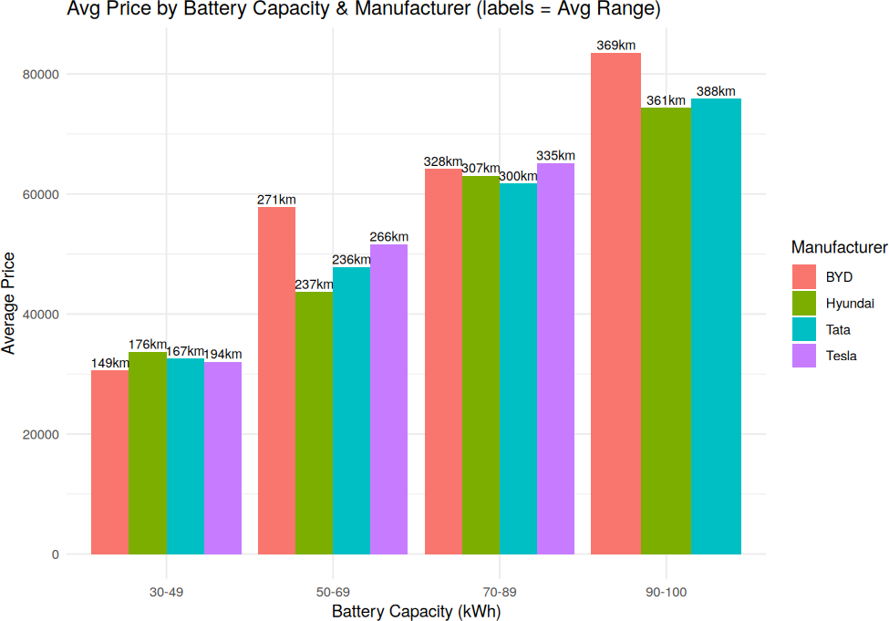

Scenario 3 - Hospital Patient Admission Analysis

Program
library(ggplot2)

depts &lt;- c('Cardiology','Orthopedics','Pediatrics','Neurology','ENT') patients &lt;- c(120,95,150,60,80)
cost &lt;- c(45000,32000,18000,52000,15000)
df3 &lt;- data.frame(Department=depts, Patients=patients, Cost=cost)

ggplot(df3, aes(x=Department, y=Patients, fill=Department)) + geom_col() +
geom_text(aes(label=paste0("Rs.", Cost)), vjust=-0.4, size=3.3) + labs(title="Patient Admissions by Department (label=Avg Treatment Cost)",
y="Number of Patients") + theme_minimal() + theme(legend.position="none")

Output
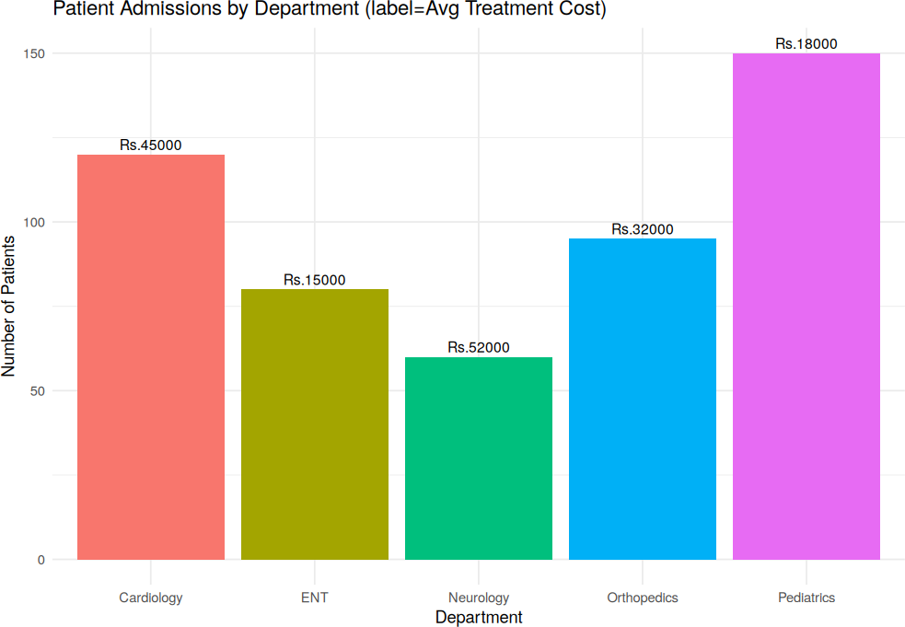

Scenario 4 - Weather Monitoring System

Program
library(ggplot2) library(dplyr)

set.seed(1)
days &lt;- seq(as.Date("2026-06-01"), by="day", length.out=30) cities &lt;- c('Chennai','Delhi','Mumbai')
base_temp &lt;- c(Chennai=33, Delhi=38, Mumbai=30)

df4 &lt;- data.frame() for (city in cities) {
temp &lt;- base_temp[[city]] + cumsum(rnorm(30, 0, 1.5))*0.1
df4 &lt;- rbind(df4, data.frame(Date=days, Temperature=temp, City=city))
}

ggplot(df4, aes(x=Date, y=Temperature, color=City, linetype=City)) + geom_line(size=1) +
labs(title="Daily Temperature Trend by City", y="Temperature (C)") + theme_minimal() +
theme(axis.text.x=element_text(angle=45, hjust=1))

Output
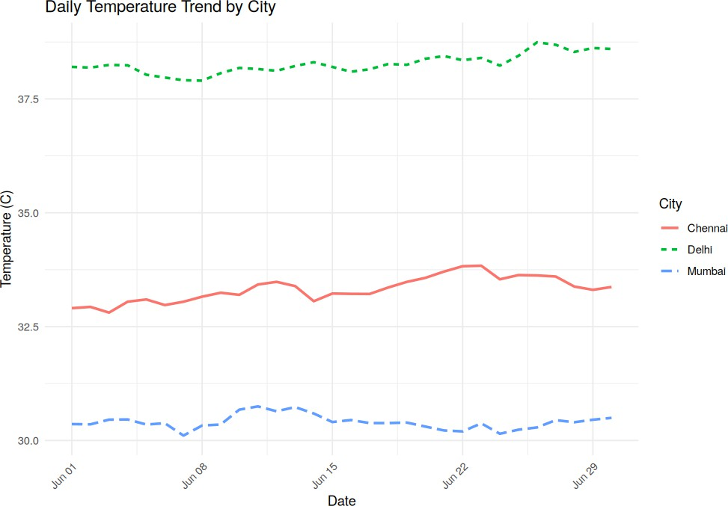

Scenario 5 - Supermarket Sales Analysis

Program
library(ggplot2)

set.seed(1)
months &lt;- c('Jan','Feb','Mar','Apr')
categories &lt;- c('Grocery','Electronics','Clothing') branches &lt;- c('Branch A','Branch B','Branch C')

df5 &lt;- expand.grid(Month=months, Category=categories, Branch=branches) df5$Sales &lt;- sample(5000:20000, nrow(df5), replace=TRUE)

jan_data &lt;- df5[df5$Month=='Jan', ]

ggplot(jan_data, aes(x=Category, y=Sales, fill=Branch)) + geom_col(position=position_dodge()) + labs(title="Product Category Sales by Branch (Jan)") + theme_minimal()

Output
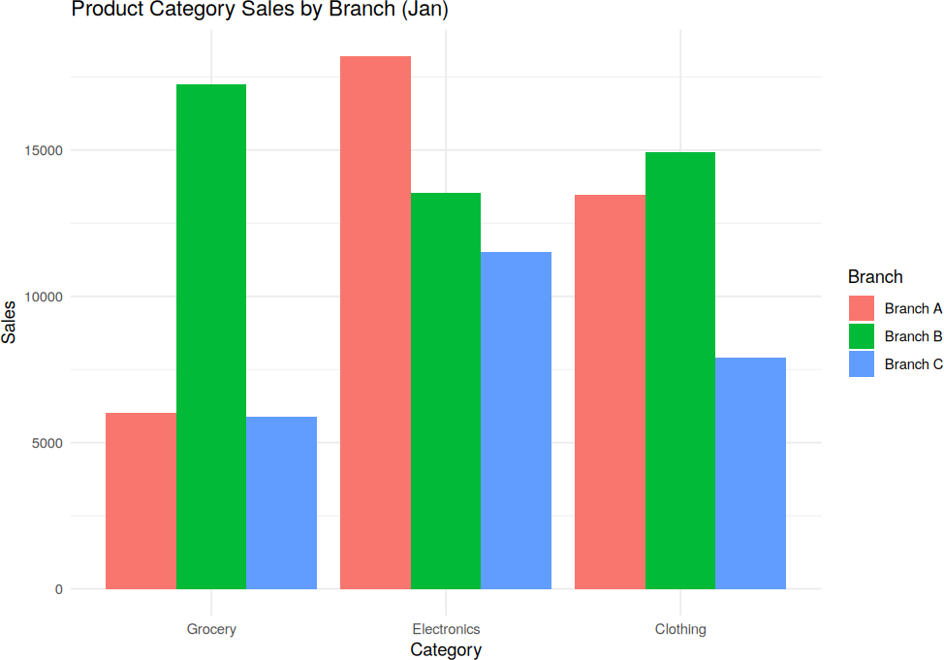

Scenario 6 - Employee Salary Distribution

Program
library(ggplot2) library(gridExtra)

set.seed(1)
salary &lt;- rnorm(300, 60000, 15000) df6 &lt;- data.frame(Salary=salary)

p1 &lt;- ggplot(df6, aes(x=Salary)) + geom_histogram(bins=10, fill="steelblue") + labs(title="Bins=10") + theme_minimal()

p2 &lt;- ggplot(df6, aes(x=Salary)) + geom_histogram(bins=40, fill="darkorange") + labs(title="Bins=40") + theme_minimal()

grid.arrange(p1, p2, ncol=2, top="Salary Distribution: Bin Size Comparison")

Output
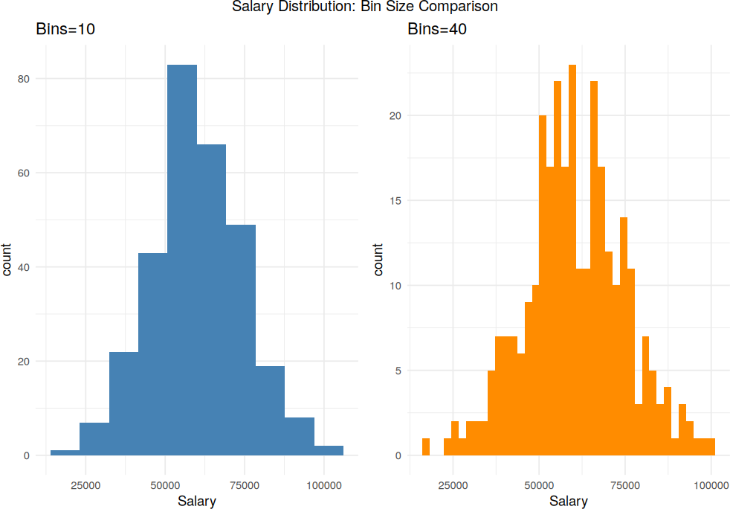

Scenario 7 - Smartphone Market Comparison

Program
library(ggplot2) library(dplyr)

set.seed(1) n &lt;- 50
brand &lt;- sample(c('Samsung','Apple','OnePlus','Xiaomi'), n, replace=TRUE) ram &lt;- sample(c(4,6,8,12,16), n, replace=TRUE)
storage &lt;- sample(c(64,128,256,512), n, replace=TRUE) speed &lt;- runif(n, 2.0, 3.5)
price &lt;- ram*3000 + storage*10 + speed*5000 + rnorm(n, 0, 3000)
df7 &lt;- data.frame(Brand=brand, RAM=ram, Storage=storage, Speed=speed, Price=price)

grouped &lt;- df7 %&gt;% group_by(RAM, Brand) %&gt;% summarise(AvgPrice=mean(Price), AvgSpeed=mean(Speed), .groups='drop')

ggplot(grouped, aes(x=factor(RAM), y=AvgPrice, fill=Brand)) + geom_col(position=position_dodge()) + geom_text(aes(label=paste0(round(AvgSpeed,1),"GHz")),
position=position_dodge(width=0.9), vjust=-0.3, size=3) + labs(title="RAM vs Avg Price by Brand (labels = Avg Processor Speed)",
x="RAM (GB)", y="Average Price") + theme_minimal()

Output
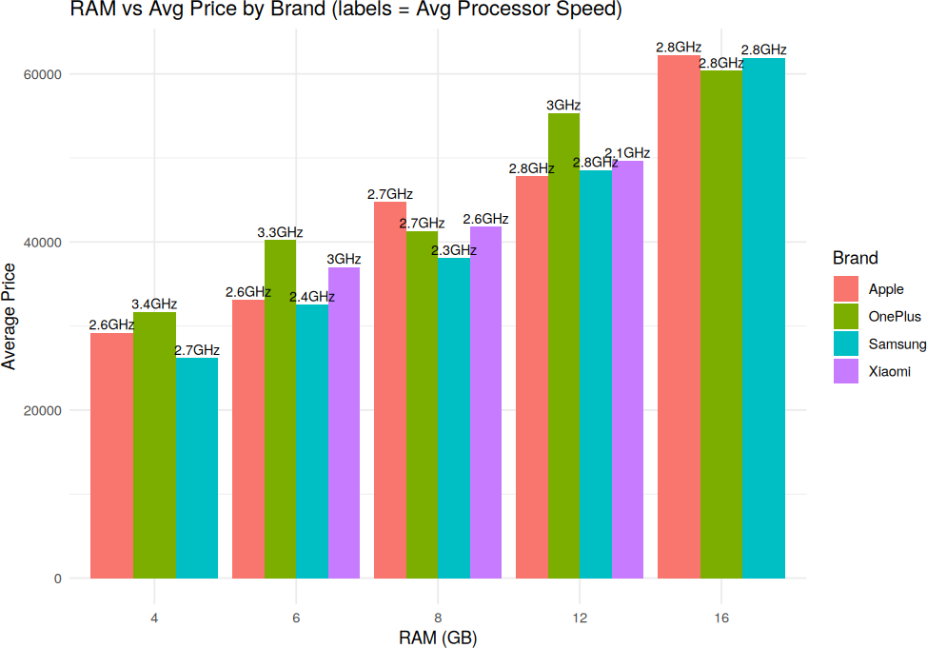

Scenario 8 - Online Movie Rating Analysis

Program
library(ggplot2)

set.seed(1)
genres &lt;- c('Action','Comedy','Drama','Horror','Sci-Fi') years &lt;- c(2021,2022,2023,2024)

df8 &lt;- expand.grid(Genre=genres, Year=years) df8$Rating &lt;- runif(nrow(df8), 5.5, 9.0)

ggplot(df8, aes(x=factor(Year), y=Genre, fill=Rating)) + geom_tile(color="white") + geom_text(aes(label=round(Rating,1)), size=3.3) + scale_fill_gradient(low="yellow", high="red") +
labs(title="Average Rating by Genre &amp; Year", x="Year", y="Genre") + theme_minimal()

Output
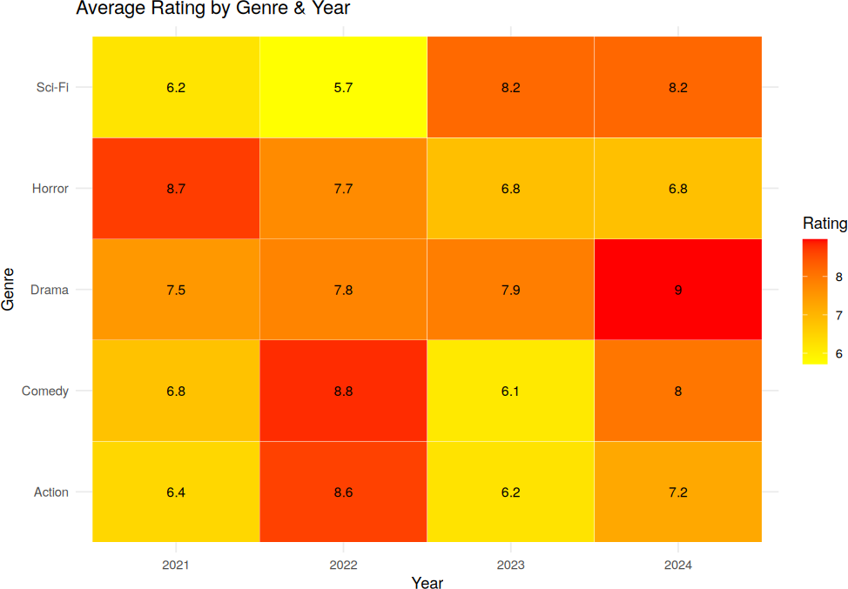

Scenario 9 - COVID-19 State-wise Analysis

Program
library(ggplot2) library(dplyr)

set.seed(1)
states &lt;- c('TN','KA','MH','DL','UP','WB','KL','GJ')
active_cases &lt;- sample(500:15000, length(states))
df9 &lt;- data.frame(State=states, ActiveCases=active_cases) %&gt;% arrange(desc(ActiveCases))
df9$State &lt;- factor(df9$State, levels=df9$State)

ggplot(df9, aes(x=State, y=1, fill=ActiveCases)) + geom_tile(color="white") + geom_text(aes(label=ActiveCases), size=3.3) + scale_fill_gradient(low="white", high="darkred") +
labs(title="State-wise Active COVID-19 Cases (Sequential Scale)") + theme_minimal() +
theme(axis.title.y=element_blank(), axis.text.y=element_blank())

Output
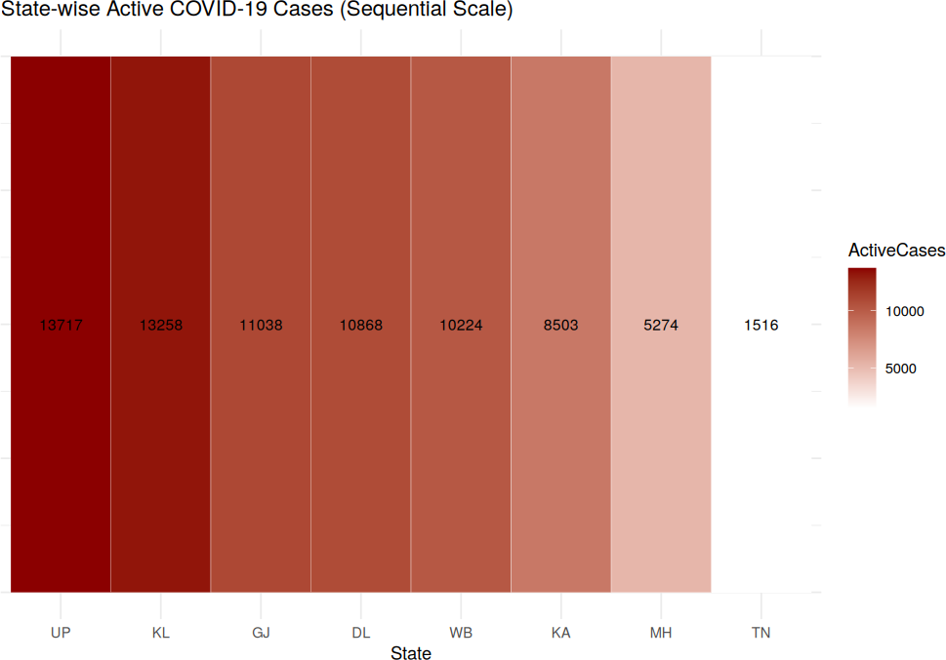

Scneario 10 - Iris Flower Classification

Program
library(ggplot2) library(gridExtra)

data(iris)

p1 &lt;- ggplot(iris, aes(x=Species, y=Sepal.Length, fill=Species)) + geom_boxplot() +
labs(title="Sepal Length by Species") + theme_minimal() + theme(legend.position="none")

p2 &lt;- ggplot(iris, aes(x=Species, y=Petal.Length, fill=Species)) + geom_boxplot() +
labs(title="Petal Length by Species") + theme_minimal() + theme(legend.position="none")

grid.arrange(p1, p2, ncol=2, top="Species Separation via Sepal/Petal Length (Box Plots)")

Output
